ASSIGNMENT 01
K. Veda sri - 2303A52382(B45)
Task 1: AI-Generated Logic Without Modularization (String Reversal Without Functions)

PROMPT :
Write a simple Python program that takes a string from the user using input, reverses it using a loop directly in the main code without using functions or slicing, and prints the reversed string.

CODE:
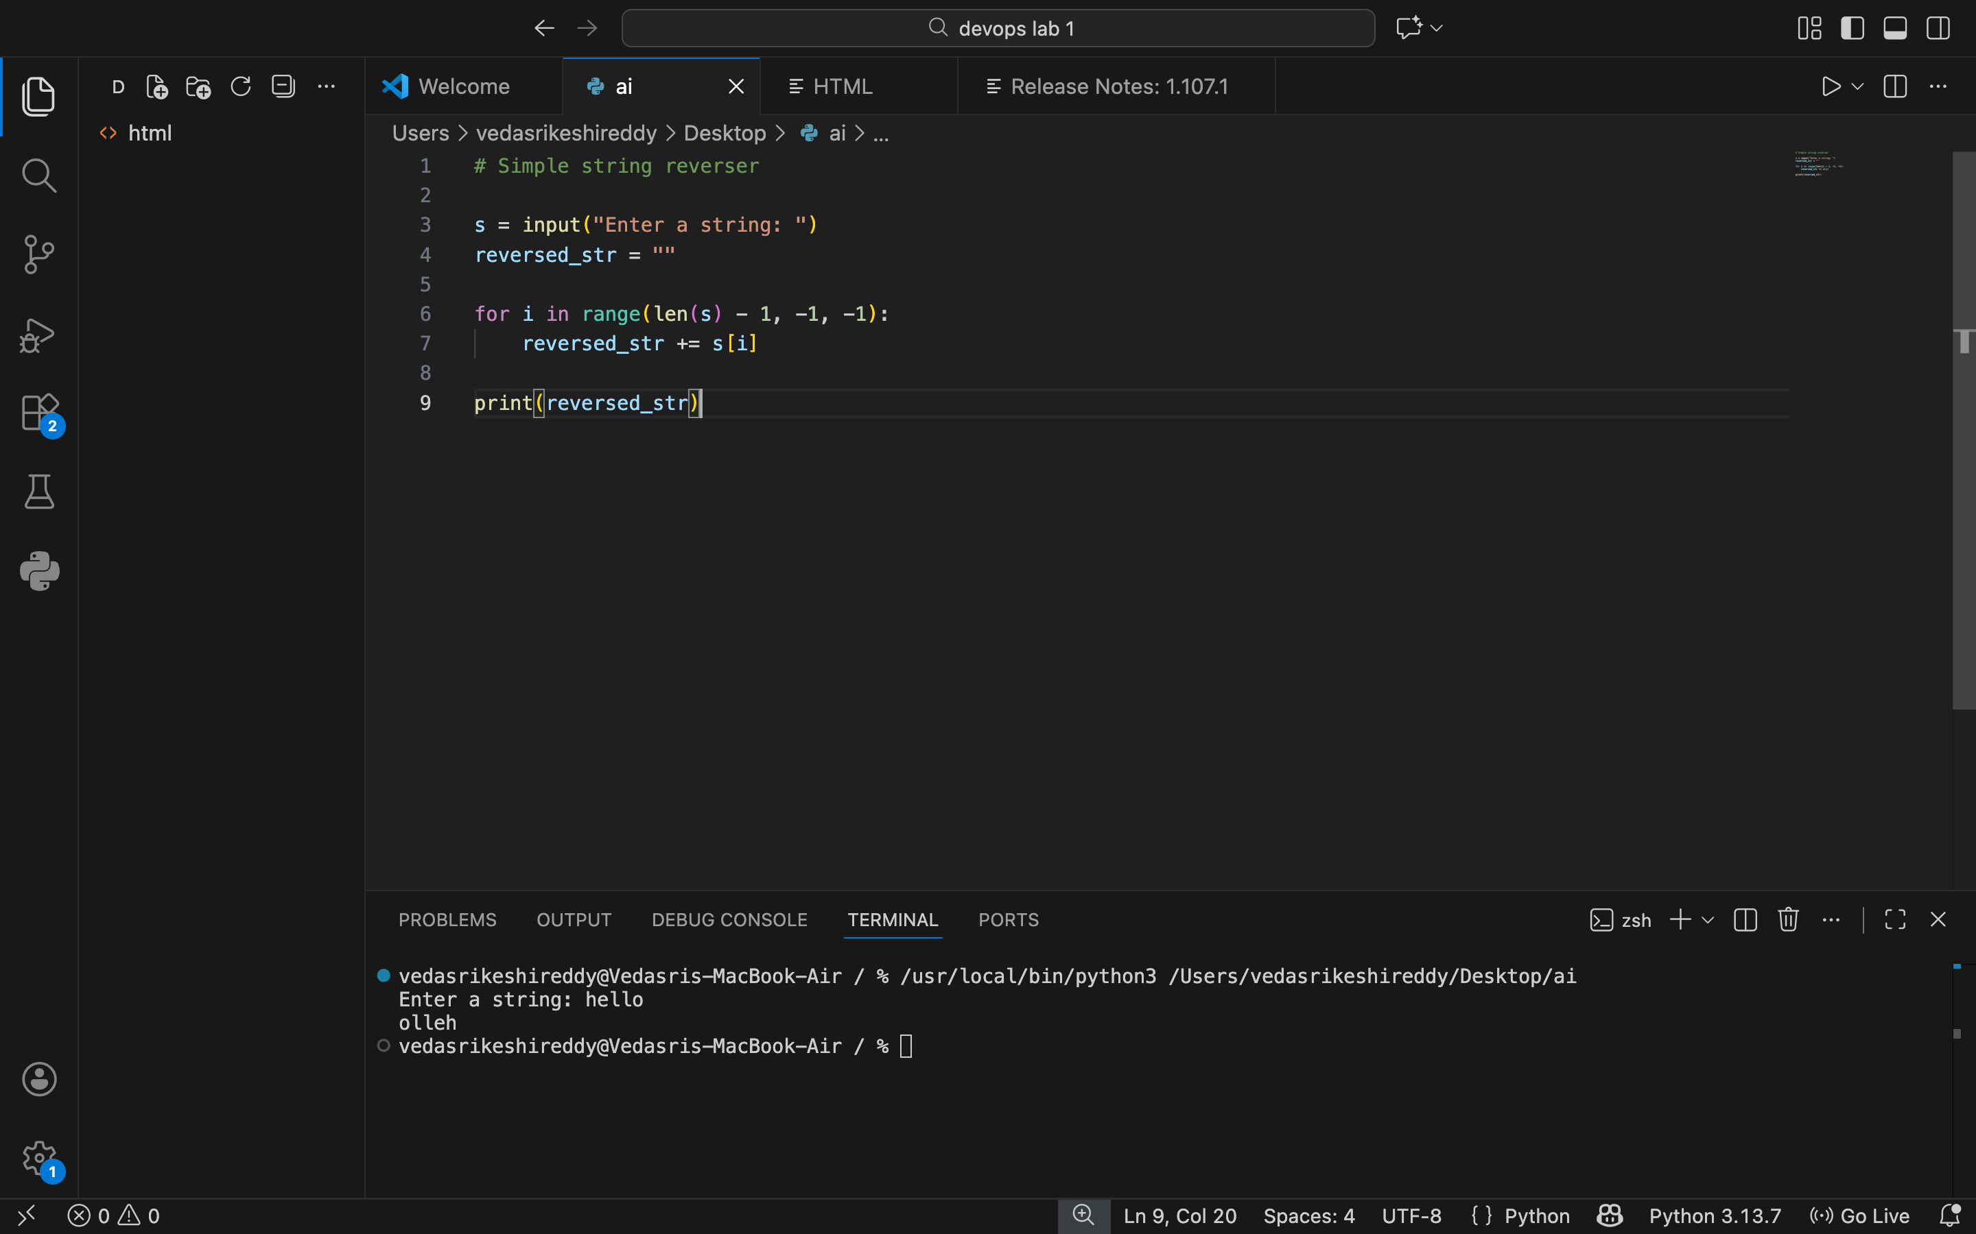

OUTPUT:
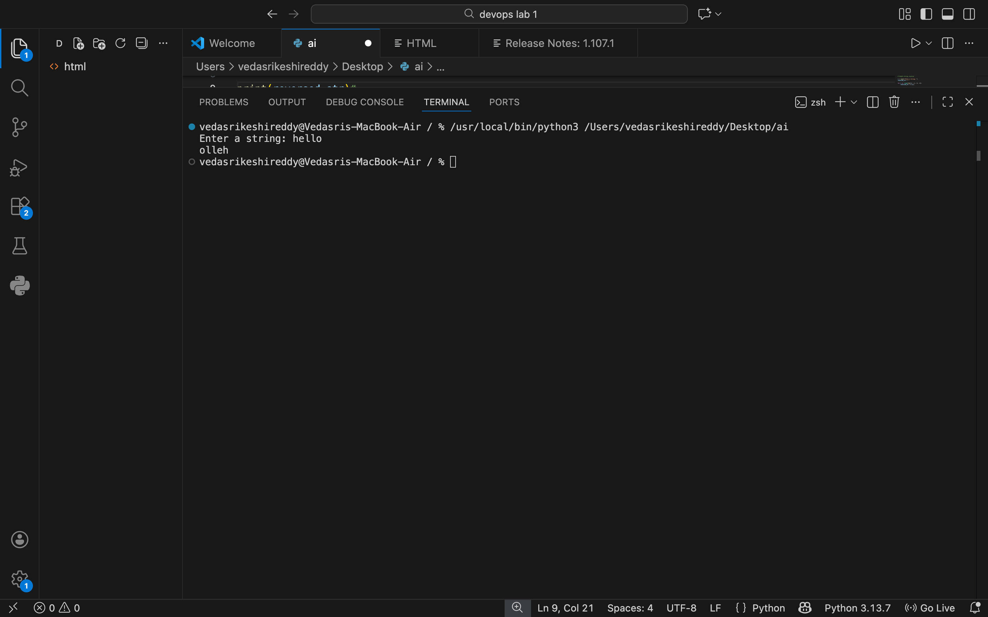

JUSTIFICATION:
This prompt is designed to help generate a basic Python program that focuses on understanding core logic rather than shortcuts. By taking input directly from the user and reversing the string using a loop in the main code, it ensures that the programmer practices how loops work and how characters are processed one by one. Avoiding functions and slicing keeps the solution simple and beginner-friendly, making the logic easy to read, trace, and understand. Printing the reversed string at the end clearly shows the result of the logic, which is useful for learning and code review.

Task 2: Efficiency & Logic Optimization (Readability Improvement)

PROMPT:
Optimize and simplify the following Python string reversal code so, removes unnecessary variables, improves readability, and produces the same output.

CODE:
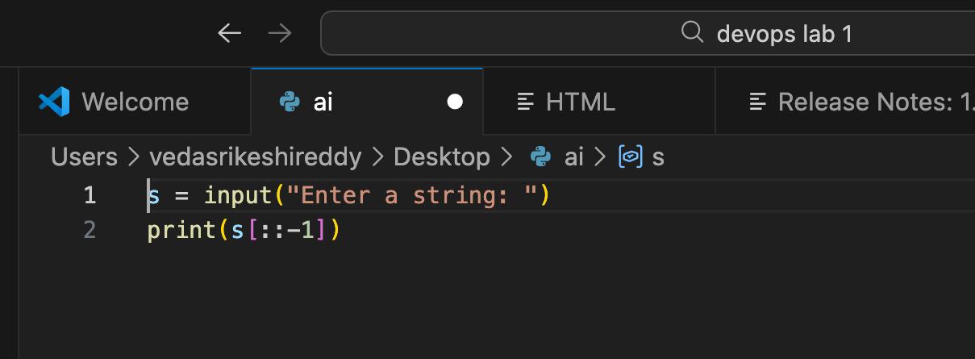

OUTPUT:
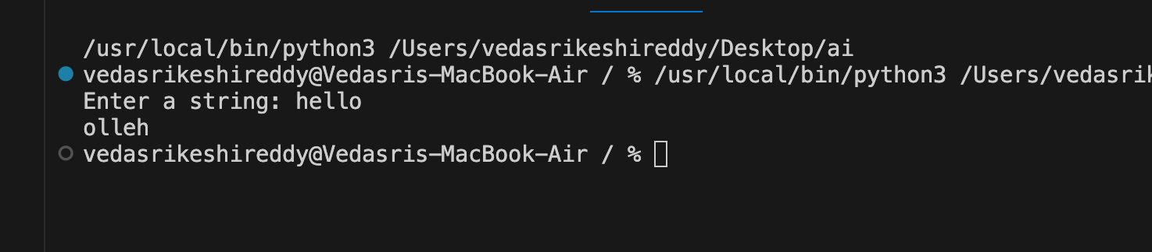

JUSTIFICATION:
This prompt asks for improving the existing code without changing what it does. By removing unnecessary variables, the code becomes shorter and less confusing. Improving readability makes the code easier for other developers to understand and review. Keeping the same output ensures that the program still works correctly while becoming cleaner, clearer, and more efficient to maintain.

Task 3: Modular Design Using AI Assistance (String Reversal Using Functions)

PROMPT:
Create a Python function that reverses a string, returns it, and includes meaningful comments, then test it with user input.

CODE:
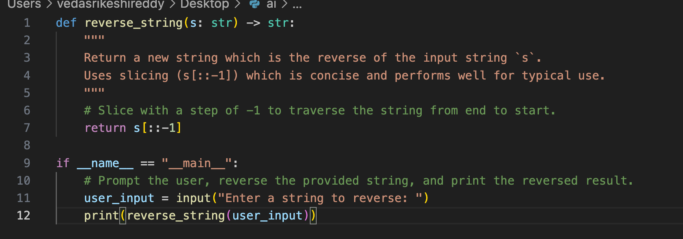

OUTPUT:
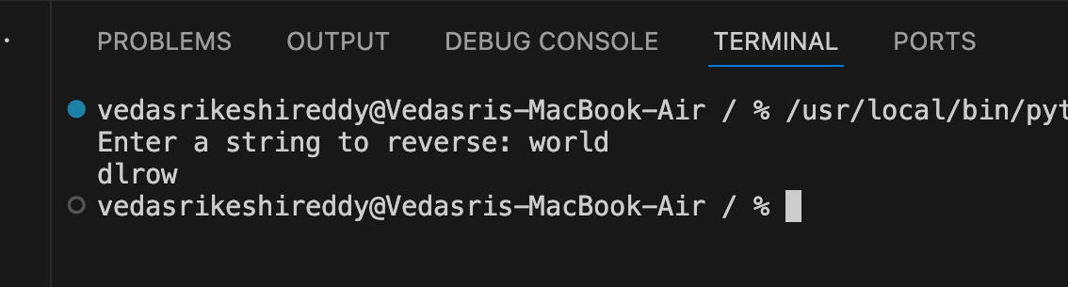

JUSTIFICATION:
This prompt encourages writing the string reversal logic inside a function so it can be reused in different parts of a program. Returning the reversed string makes the function flexible and easy to test. Adding meaningful comments helps explain what the code is doing, which is useful for beginners and for other developers reading the code. Testing the function with user input ensures that it works correctly in real situations.

Task 4: Modular Design Using AI Assistance (String Reversal Using Functions)

PROMPT:
Compare two Python programs for string reversal—one written without functions and one using a user-defined function—and provide a concise comparison based on code clarity, re-usability, ease of debugging, and suitability for large-scale applications in a table or short analytical report.

CODE:

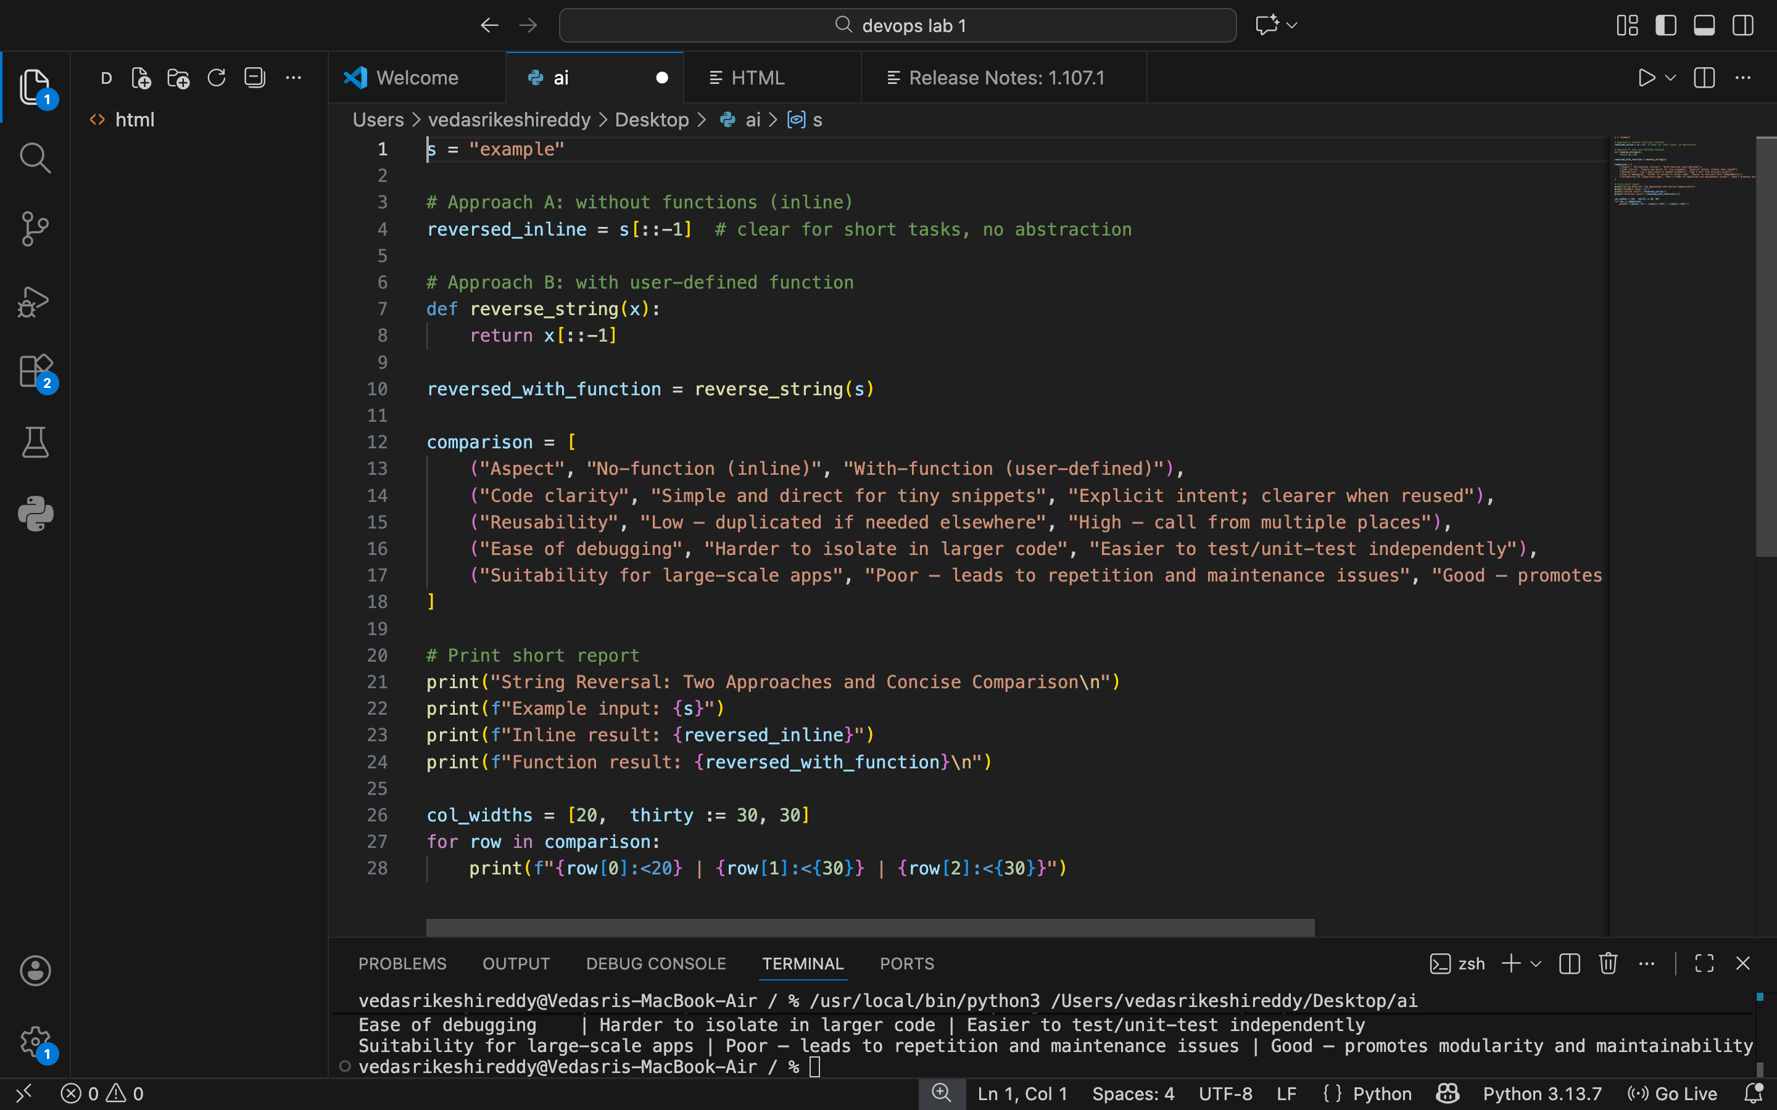

OUTPUT:
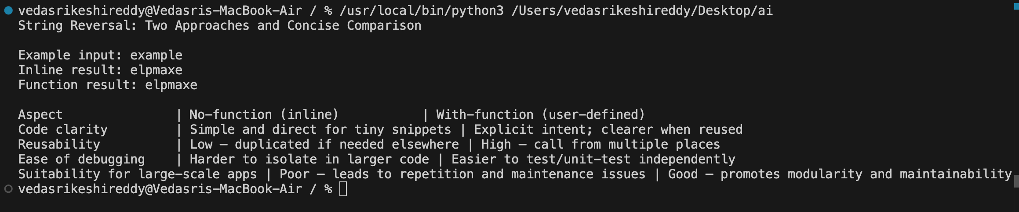
JUSTIFICATION:
This prompt is used to understand the differences between writing code in a simple procedural way and using functions. By comparing both approaches, it becomes easier to see which code is clearer to read, easier to reuse, and simpler to debug. The comparison also helps explain why function-based code is more suitable for large and real-world applications. Presenting the analysis in a table or short report makes the differences easy to understand during a code review.

Task 5:AI-Generated Iterative vs Recursive Fibonacci Approaches (Different
Algorithmic Approaches to String Reversal)

PROMPT:Generate two Python string reversal programs—one using a loop and one using slicing—and then compare them based on execution flow, time complexity, performance on large inputs, and appropriate use cases.

CODE:
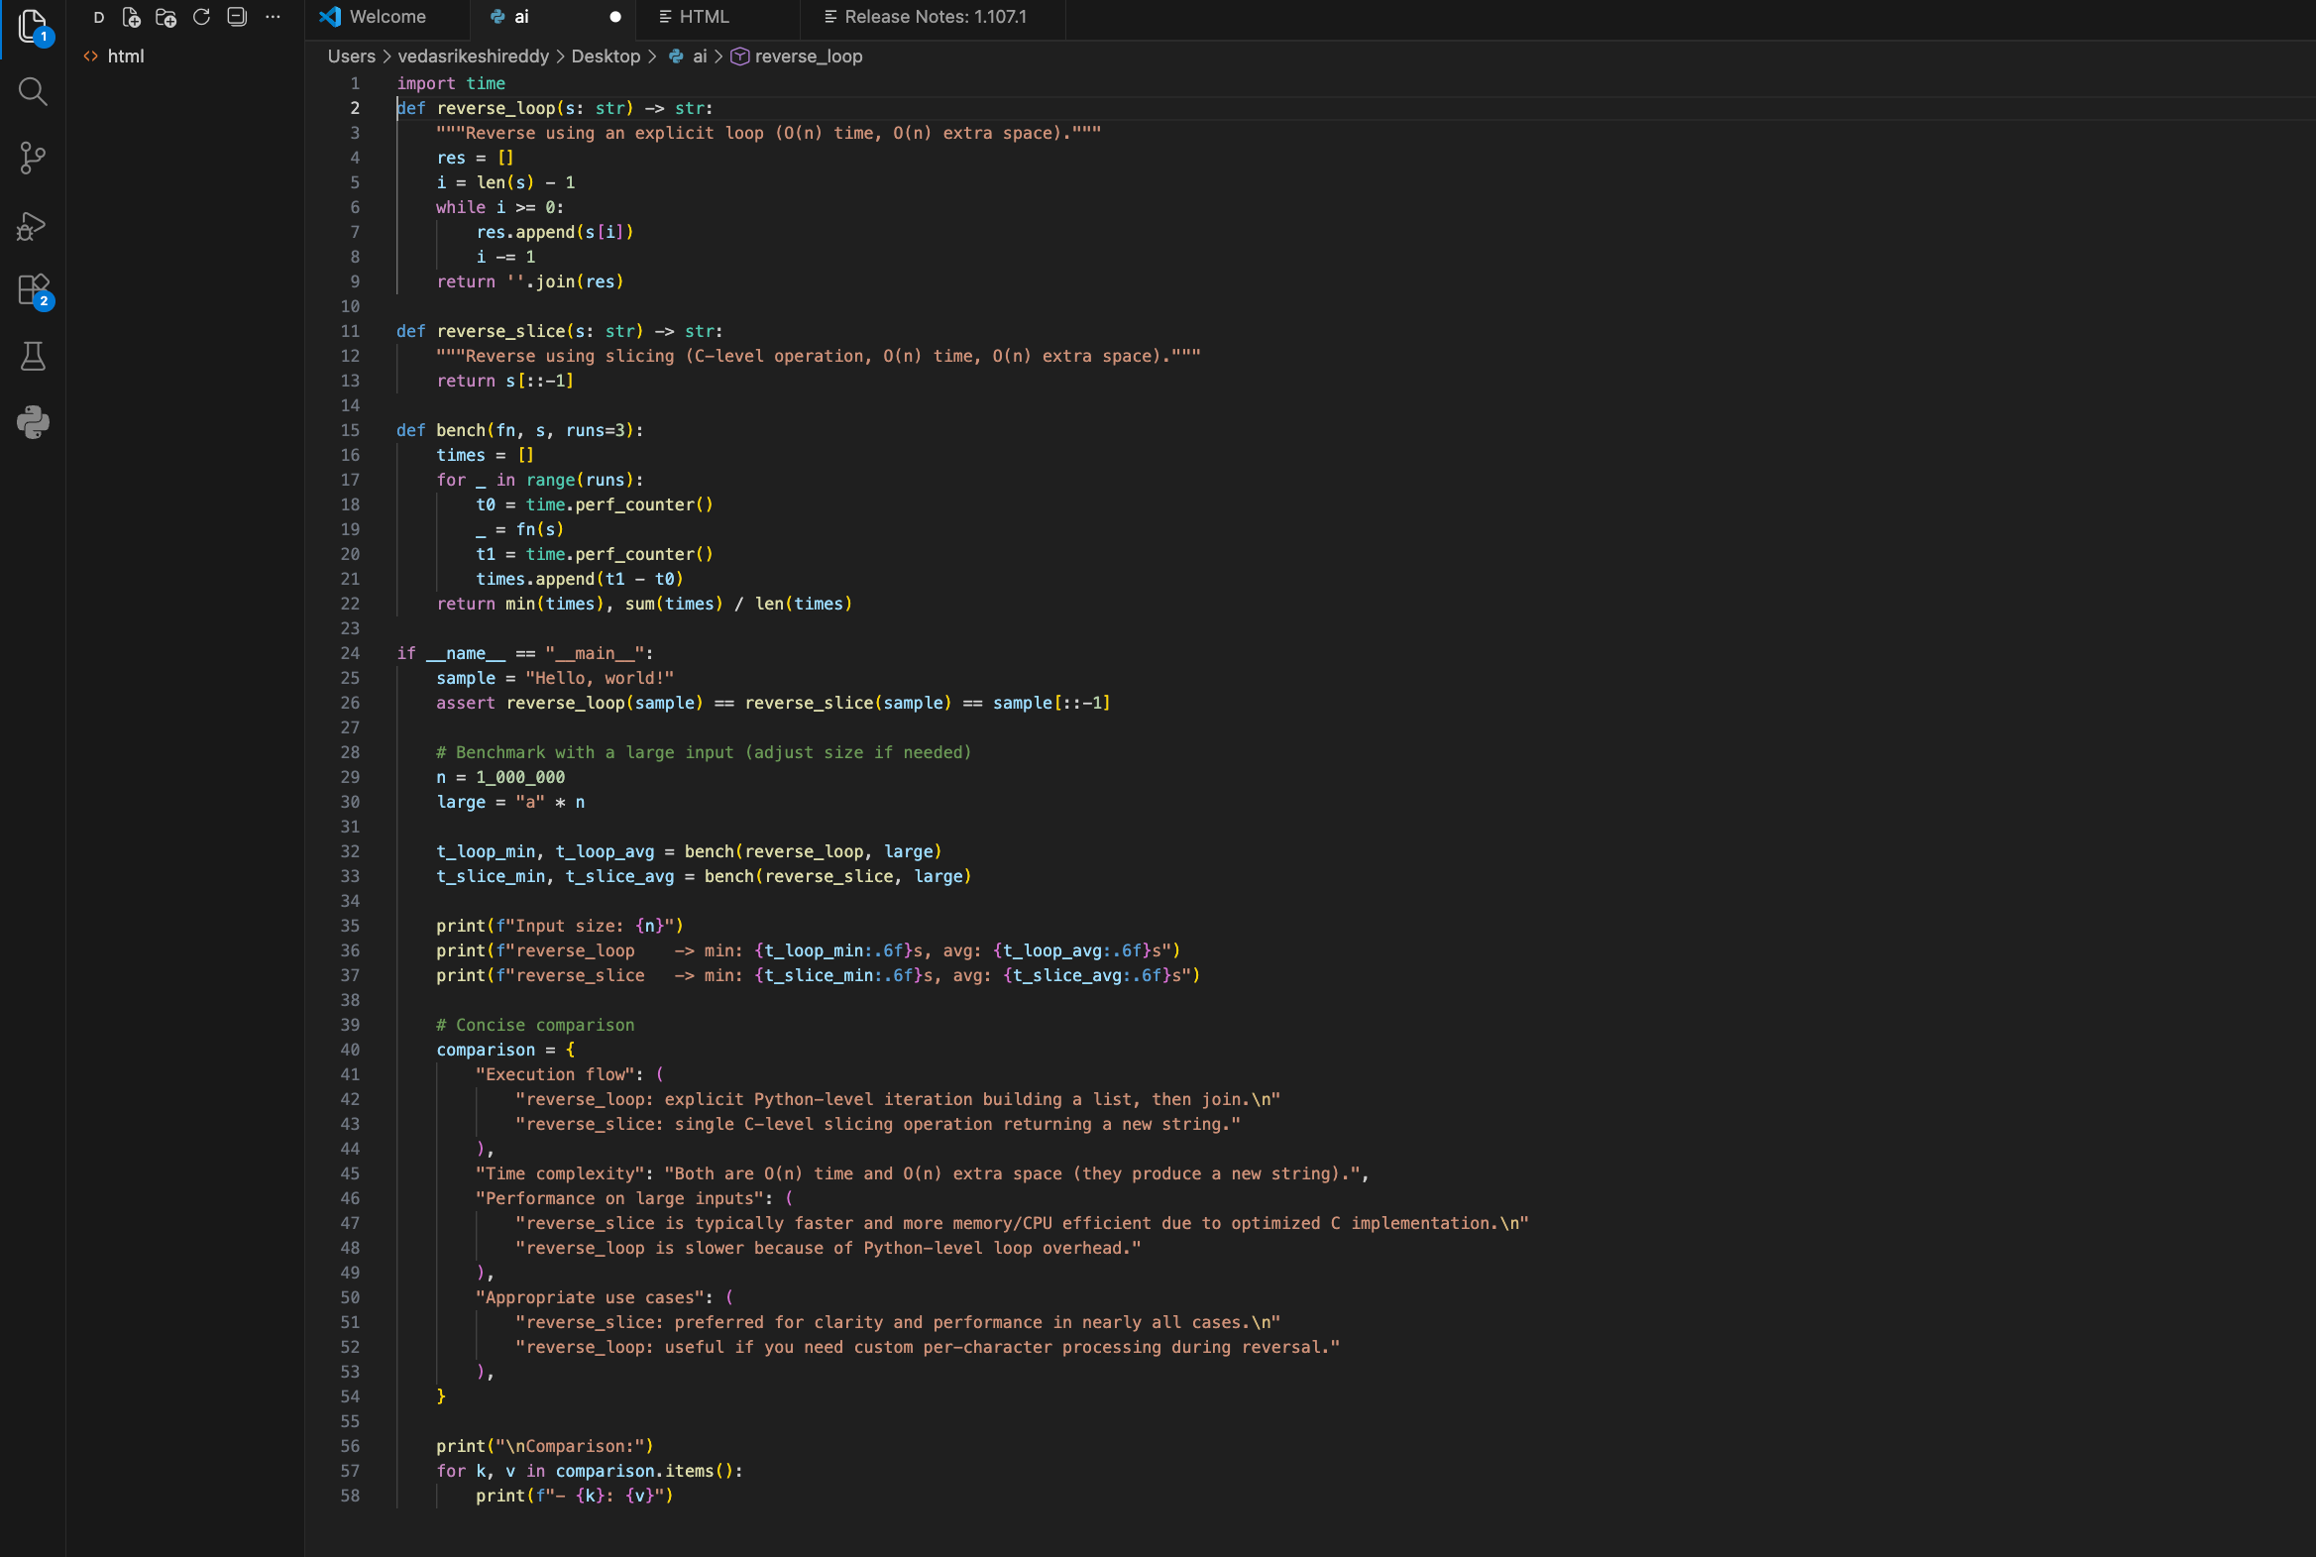
OUTPUT:
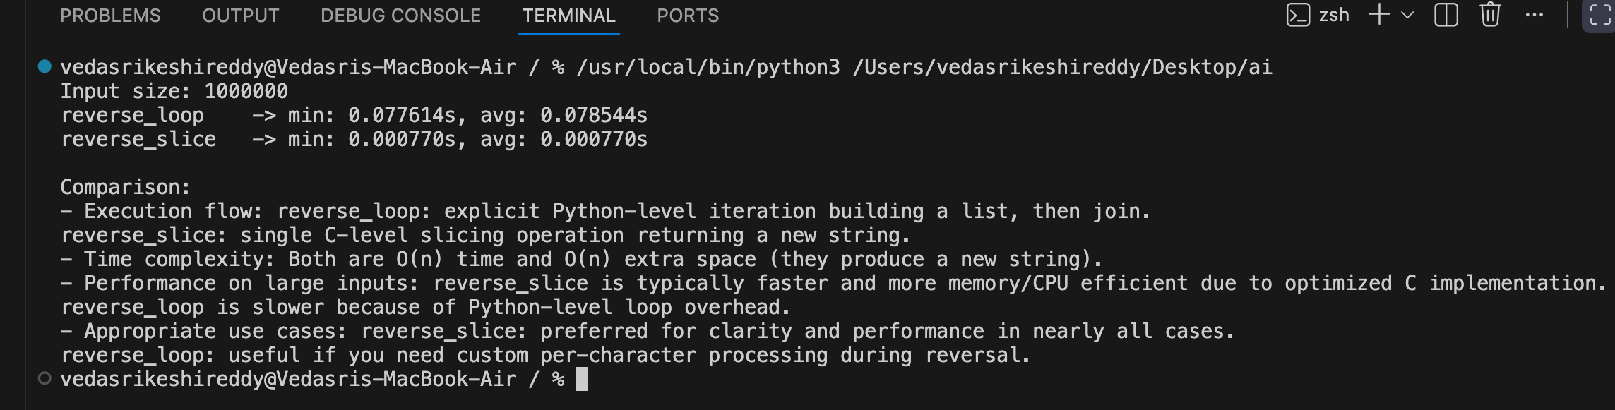
JUSTIFICATION:
This task helps us understand that the same problem can be solved in different ways. The loop-based method explains the logic clearly step by step, which is good for learning, while the slicing method is shorter, cleaner, and faster to write. Comparing both helps us decide which approach is better based on performance, readability, and real-world usage.

